Week 3 • Predicting Reactions
LABORATORY AND DEMONSTRATION IDEAS

Overview:
Talking about all of these different types of reactions is fine, but students need to get in the lab and see them for themselves. I have tried to organize these ideas by the four types of reactions we study: Double Replacement, Oxidation-Reduction, Lewis Acid-Base, and Complex Ions.

Laboratory Ideas:
Double Replacement
Precipitate Lab  I believe that this is a standard lab. We use eight dropper bottles of chemicals. We place the data table in a large Ziploc bag and do the reactions directly on the plastic. One feature we have added is to color in half the box so the mixture can be viewed on a light and dark background simultaneously. This helps students see the precipitates. We explain that we are looking for cloudiness. Cloudiness means little bits of solid are formed. If we leave the chemicals long enough, the cloudiness settles to the bottom, that is why they are called “precipitates” (like rain and snow).  We take each pair of (aq) solutions and decide what the two new combinations will be. Knowing that some ions (Na⁺, K⁺, NO₃⁻) would rather be dissolved in water than combined with other ions (a precipitate) we decide on the solid product(s) in each case where a reaction occurs (16 precipitates). We then learn to write molecular, ionic, and net ionic equations. After this, we learn the solubility rules. | 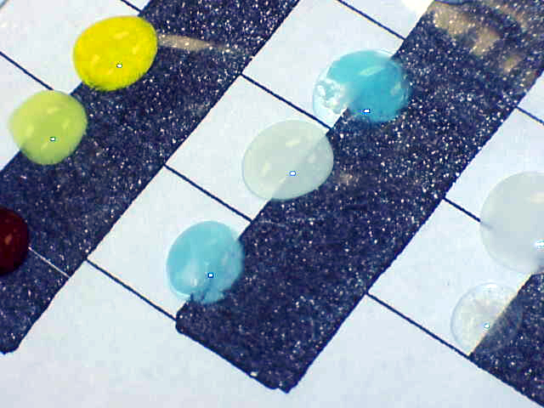
 | 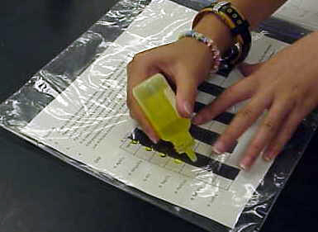

Strong & Weak Electrolyte Demo  We test 12 household products with cabbage juice to find categories of chemicals (acids, bases, neutrals), next we test some of the products with a conductivity apparatus and define strong and weak (and non) electrolytes.  I make the point that the HCl and the vinegar are nearly the same concentration, but the HCl is a strong electrolyte and the vinegar is a weak electrolyte. HCl exists primarily as separate ions in solution whereas vinegar dissolves, but does not dissociate into ions. When we write the ionic equation, strong acids will be written as separate ions, but weak acids are written as molecules.  Acids: 1 M hydrochloric acid (swimming pool acid), vinegar, Gatorade (some colorless flavor), lemon juice.  Bases: Red Devil Drain Cleaner (NaOH), household ammonia (diluted 50% with distilled water), Milk of Magnesia (unflavored and diluted with distilled water), Washing soda, Na₂CO₃ dissolved in distilled water.  Neutrals: Rock Salt dissolved in distilled water, 99% Rubbing Alcohol, 3% hydrogen peroxide, lamp oil (hydrocarbon). |  | 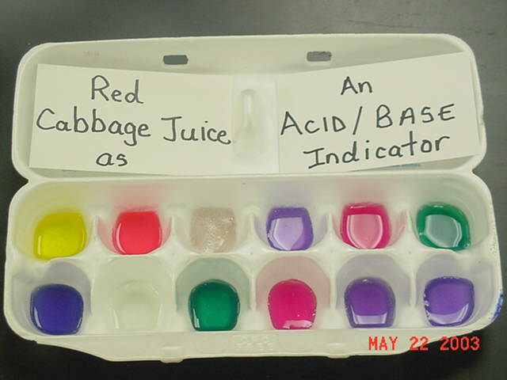
 |  | 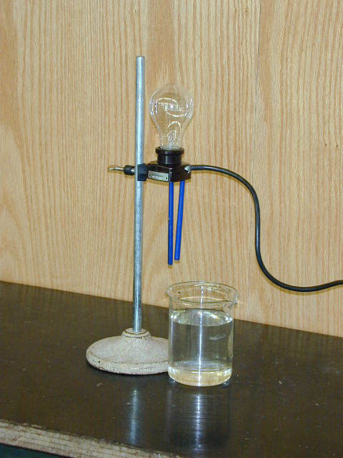
Silver One Pot Reaction  I remember my high school teacher doing this as a demonstration. I don’t do this myself because of the cost of silver nitrate, however, this is a micro-scale version of the one-pot reaction. Successive precipitates are formed, each less soluble than the one before. Some complex ions are more stable than the precipitates and give a series of different products. There is a procedure for this on Dave Brooks’ website at UNL. See the External Link button?  [http://dwb.unl.edu/dwb/Meetings/Oct-8-99/ComplexIonsTutor.html] | 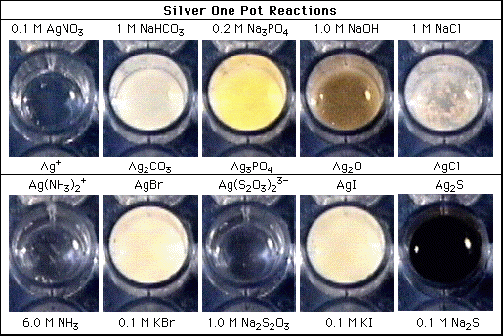

Gas Formation in a Baggie Demo  Double replacement that produces H₂CO₃, H₂SO₃, HNO₂, or NH₄OH results in gases being formed. Vinegar and baking soda forming H₂CO₃ and therefore CO₂(g) can be demonstrated in a beaker. However I like to demonstrate the formation of NO₂ gas this way. Place some sodium nitrite in a baggie. Place dilute HCl solution in a vial. Stand the vial up inside the baggie, seal the baggie, and then spill the acid onto the NaNO₂. The red-brown gas will form inside the baggie and no one needs to smell the irritating gas.  Note: This picture is from a different lab, but you get the idea. | 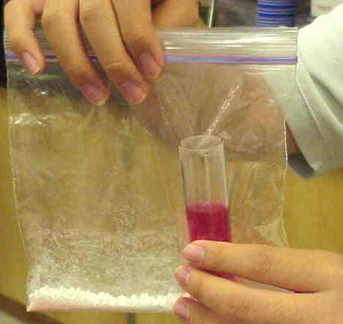

Hands-On Lab
Another gas-formation activity can take place in the students’ hands. I read this in an old “Sourcebook for the Physical Sciences” book. You might not want to have students touch chemicals. I have students take a pinch of ammonium chloride in one hand and a pinch of calcium hydroxide in the other hand. They rub the two solids together and then carefully waft the mixture. NH₃(g) is formed. The students wash their hands right after.

Oxidation-Reduction:
Growing Crystals in Gels  This is a cool laboratory activity that involves a double replacement reaction as well as two oxidation-reduction reactions. Usually, we look for ways to speed up reactions. In this lab, you form a gel using sodium silicate solution and mix a chemical in it. When you add another chemical, the products form slowly (over a week or so) and so the crystals are larger and beautiful to observe. The lab is outlined in FlinnFax, Volume 97-1. I’ve emailed Flinn and asked for a copy. The close-ups show how pretty this is. | 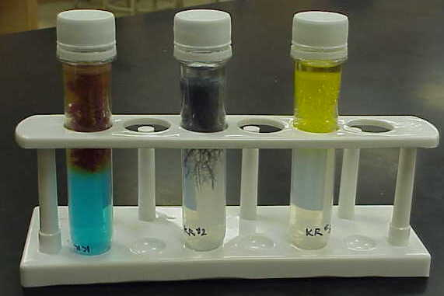

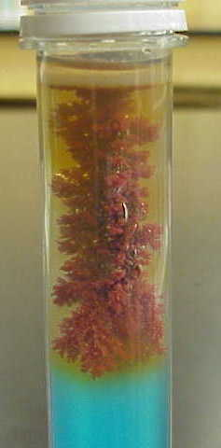  CuSO₄ in gel, Fe (paperclip) stuck into surface. Cu(s) forms. | 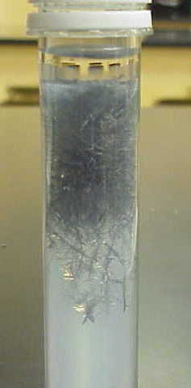  Pb(NO₃)₂ in gel, Zn(s) stuck into surface. Pb(s) forms. | 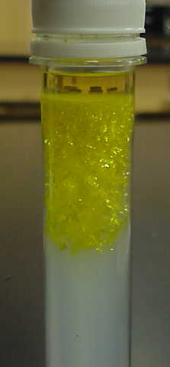  Pb(NO₃)₂ in gel, KI(aq) floated on top. PbI₂(s) forms.
I run this reaction in preforms (2-Liter bottles before they become 2-Liter bottles) so there is a top that we can superglue closed. The students can take these tubes home with them as a souvenir of chemistry. I have students work in teams of three and each student gets one tube.

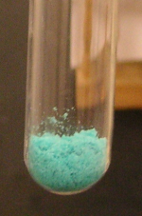  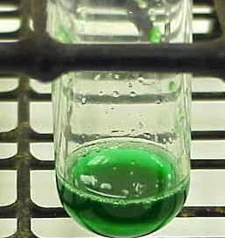 | Introduction to Oxidation-Reduction:  A little CuCl₂(s) is placed in a medium-sized test tube. A few drops of distilled water are added and the students note the green color. When more water is added, the characteristic blue Cu²⁺(aq) color appears. A piece of aluminum foil is added. A red-brown solid forms on the foil that looks like rust (Cu solid). The reaction mixture bubbles (H₂ gas) and gets very hot. We concentrate on the reduction of the copper ions and the oxidation of aluminum metal into aluminum ions.  Note: Sorry about the poor quality of the picture to the right.  Note: We acknowledge, but ignore, the side reaction in which the hydrogen in the water is being reduced to H₂(g). I think this occurs because of the high temperature at the metal surface.  Note: the green color formed when just a small amount of water is formed is a good time to discuss complex ions, CuCl₄²⁻(aq) although the green color is probably due to Cu(H₂O)₂Cl₂. | 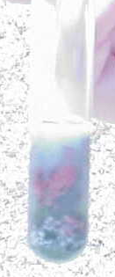

Very Simple (and Safe) Thermite Demonstration  Flinn sells two large ball bearings (3” in diameter). Both are rusty, but one is covered with aluminum foil. When you strike the two together, the iron oxide and aluminum metal react to form iron metal and aluminum oxide. The reaction releases enough heat to burn the iron and you get an impressive spray of white sparks. 2Al + Fe₂O₃ → Al₂O₃ + 2Fe | 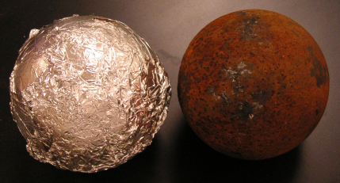

Lewis Acid-Base
Dry Ice in Water Demo  Oxides of nonmetals turn into acids when they react with water.  CO₂(g) + H₂O(l) → H₂CO₃(aq)  A standard way to demonstrate this is to fill 1-L cylinders with water and various acid-base indicators. I like universal indicator. Make the solution a little basic before you begin. Add a small chunk of dry ice, CO₂(s), and observe the color change as the solution becomes more and more acidic. Bassam Shakhashiri always has two identical cylinders and adds dry ice to only one so you have a comparison cylinder. | 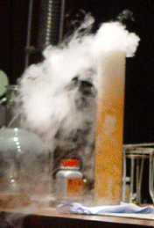

Bubble NO₂ into Water Demo  On my first day of AP chemistry, I perform the “nitric acid acts on copper” demonstration. I pass the NO₂(g) that is formed into a small aquarium to absorb the NO₂(g).  I repeat this demonstration later in the year and make the water in the aquarium a little basic and add universal indicator. Students can see the color change as the NO₂(g) forms nitrous acid and nitric acid.  2NO₂(g) + H₂O(l) → HNO₂(aq) + HNO₃(aq) | 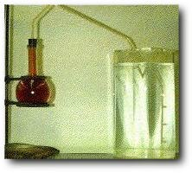

Complex Ions
Complex Ion Lab
The students go through a series of reactions with Cu²⁺ ion. First we observe the blue color, Cu(H₂O)₄²⁺,(aq) then add a little NaOH(aq) to get the light blue precipitate, Cu(OH)₂(s). Next we add concentrated NH₃(aq) to form the beautiful indigo complex ion, Cu(NH₃)₄²⁺(aq). If we add HCl(aq), the ammonia ligand picks up an H⁺ and becomes NH₄⁺ which will no longer be attracted to the Cu²⁺ ion. The complex ion changes back into the copper(II) hydroxide precipitate and then back to the blue solution when enough HCl is added to neutralize the OH⁻ ions in solution.

