NChO 2008
ANNOTATED ANSWERS

1. | A Only two elements are liquid at room temperature and pressure (25°C & 1 atm), Br₂ & Hg.
2. | D PbI₂(s) is yellow. (Memorize this tidbit.)  Color often involves transition metal ions because the electron can be excited from one d-orbital to another. Eliminate (C) because NaNO₃ and Cu(ClO₄)₂ will not even be precipitates. Eliminate Al(OH)₃(s) and BaSO₄(s) because Al and Ba are not transition metals and will form white precipitates. |  |  |  |  | 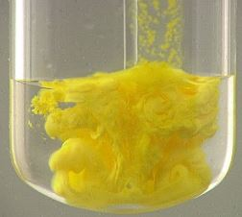
3. | A density, d = 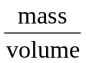so... d = 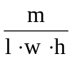 So... h = 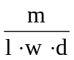 Where “h” = thickness of foil
4. | B You should eliminate (C) filter a precipitate which requires a funnel and a piece of filter paper.  You should eliminate (D) which can be done in a beaker with a piece of chromatography paper.  Distillation uses a flask where liquid is heated to a vapor and a condenser where the vapor is turned back into a liquid. During reflux, the vapor is condensed and returned to the reaction vessel. The condenser is in a vertical position so the solvent can be re-claimed and the reaction product can be concentrated. Related idea: “acid reflux” mentioned in antacid commercials. |  |  |  |  |  | 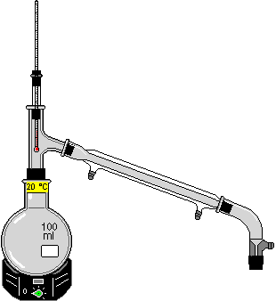
5. | D Solar cells are large silicon chips.  Si, As, and Ge are often used in computer chips. P is used in matches.
6. | A Proper technique requires that you look straight across at the lowest part of the dip in the liquid (the “meniscus”). Note: Hg makes an inverted meniscus. |  | 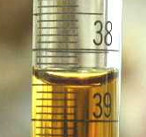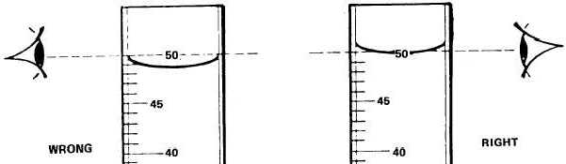
7. | C Look for the chemical with the smallest molar mass. Smaller molar mass = greater # of molecules.  The calculation is 1.0 g x 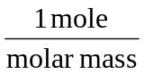x 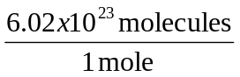
8. | C Recall that for Na₂SO₄, i=3, turns into three ions.  250 mL x 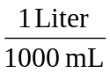x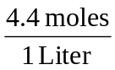x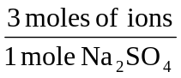= 3.3 moles
9. | D “Simple” line equation:  245 g KClO₃ x 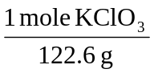x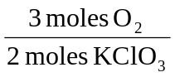= 3.00 moles
10. | B Calculate moles in each solution and divide by the total volume. Vol x M = moles.  0.050 L x 0.150 M = 0.0075 moles  0.025 L x 0.400 M = 0.100 moles  (0.0075 + 0.100) moles / 0.075 L = 0.233 M
11. | D Theoretical Yield is just the normal calculated answer to the problem:  This is a limiting reactant problem. Since the ratio of X:Y is 2:3, can probably tell that Y is the limiting reactant. 2.00 moles of Y → 2.00 moles Z (this is the Theoretical Yield). The Actual Yield was given in the problem (1.75 moles Z).  % Yield = 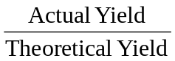x 100 = 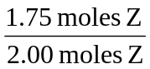x 100 = 87.5%
12. | A The boiling point is greater for a solution.  Solutions are harder to boil (BP↑) and harder to freeze (FP↓).  The boiling changes because the solution has a lower vapor pressure. Triple Point is the place where all three lines intersect.  The blue line is the solution. The pink line is the pure solvent.  Notice that the blue triple point is lower than the pink triple point.  Remember that this has nothing to do with IMF’s. The solute particles get in the way and make it harder to freeze, boil, and |  |  |  | 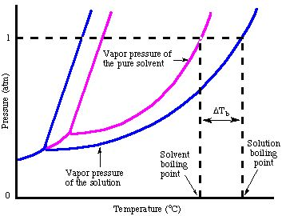
 | form vapor. Non-volatile means our solutes do not have a vapor pressure of their own. Adding alcohol to water raises the vapor pressure and lowers the boiling point... opposite to nonvolatile solutes.
13. | B Liquids take the shape of their container. Liquids DO have a definite volume, cannot be compressed, and are slower at diffusing than are gases.
14. | A If you lower the pressure above a liquid, it will boil more easily. A substance boils when its vapor pressure equals the pressure above the liquid.  Eliminate (B) only temperature changes the vapor pressure.  Eliminate (C) a gas will change to a liquid with HIGHER pressure, not lower.  Eliminate (D) a gas in a non-rigid container (like a balloon) will INCREASE in volume, not decrease.
15. | C 24.0 g Ar(g)  All gases have the same power to cause pressure. Set this up as a proportion:  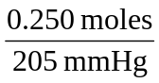 = 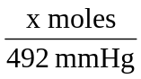; x = 0.600 moles Ar • 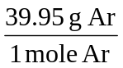= 23.97 g Ar
16. | C 0.923/1  Remember to change °C to K. Final : Initial = 25°C : 50 °C = 298 K : 323 K = 0.9226 : 1
17. | D When IMF ↑, particles cannot escape as vapor, ∴ vapor pressure ↓
18. | D polar covalent (example: sugar)  Eliminate (A) ionic (like NaCl) is soluble, but would conduct electricity.  Eliminate (B) metallic is not soluble.  Eliminate (C) network solid (like diamond) is not soluble.
19. | A enthalpy change is ΔH; for exothermic reactions, ΔH −; reaction gives off heat to the surroundings.  The entropy change, ΔS, is unrelated to exothermic. Spontaneity depends on both ΔS & ΔH.
20. | D ΔH_{f}° is the energy to form 1 mole of substance from its elements.  Eliminate (A) formed from ions, not neutral elements.  Eliminate (B) & (C) formed from molecules, not neutral elements.
21. | A 141.5  This is Hess’s Law. Remember, ΔH_{f}°(element) = 0, so they are not included.  ΔH_{reaction} = ΔH_{f}°(Products) – ΔH_{f}°(Reactants)  = ΔH_{f}°(Cu₂O) – 2 ΔH_{f}°(CuO)  = (-170.7) – 2(-156.1) = + 141.5 kJ
22. | C Na(s), NaBr(s), Br₂(l), Br₂(g) (most disordered on the right of list)  First, (s) < (l) < (g). Eliminate answers (A), (B), and (D).  Also, however, NaBr(s) will be more random than Na(s) because it has “more possible states”.
23. | B It is spontaneous only at low temperatures.  The question states that the reaction is exothermic (ΔH < 0). Additionally, by looking at the equation, 1 mole of gas turns into 0 moles of gas… this is a downward change in entropy (ΔS < 0).  When ΔH is – and ΔS is – the reaction is spontaneous (product-favored) only at low temperatures. |  |  |  |  |  | 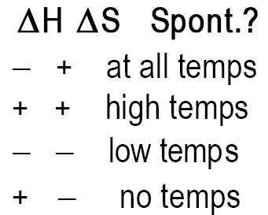  Memorize this.
24. | A -92.3 kJ  This is a ΔG = ΔH - TΔS problem. Remember to use T = 25°C + 273 = 298 K.  Also, ΔS must be changed from J to kJ. Simply solve for ΔH.
25. | A 0.025 mol·L⁻¹·sec⁻¹  You need to draw a line tangent to the curve at 10 seconds.  Estimate “rise/run” to get the slope.  I estimated 0.65 mol·L⁻¹/ 33 sec which is closest to 0.025 mol/L/sec. |  |  |  |  |  |  | 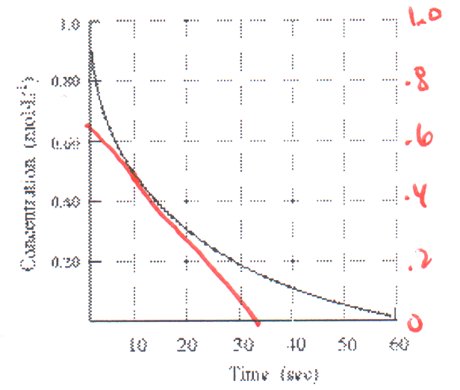
26. | D 5/3 the rate of production of CO₂.  The rates of each chemical can be made equal if you use the reciprocal of the coefficients.  1/5 O₂’s rate = 1/3 CO₂’s ∴ multiply both by 5 to get O₂’s rate = 5/3 CO₂’s rate.
27. | C two  Order is the superscript of the concentration. Since [3]² = 9, the order must be 2.
28. | B 0.50 M  t = 40 minutes t_{½} = 20 minutes. So, you have two half-lives. 2.0 M divided by 2 twice = 0.50 M.
29. | B average kinetic energy of the reactants increases.  Eliminate (A) activation energy is affected by a catalyst, not warming the reactants.  Eliminate (C) temperature speeds the reaction, but does not “catalyze” the reaction.  Eliminate (D) you get the light in a shorter period, but it should be the same wavelength.
30. | C L·mol⁻¹·min⁻¹  solve for k; k = rate / [CO][NO₂]; the units are: mol·L⁻¹·min⁻¹/mol²·L⁻²
31. | A The forward and reverse reactions occur at identical rates.  Eliminate (B) The concentrations reactants and products do not HAVE to be equal.  Eliminate (C) A catalyst does not change the equilibrium concentrations… only how fast you get there.  Eliminate (D) Changing temperature will shift equilibrium concentrations depending on whether the reaction is exothermic or endothermic.
32. | (D) CaCO₃(s)  CaO(s) + CO₂(g)  “a decrease in the amount of product” translates into “shift to the left”  If a decrease in volume (an increase in pressure) shifts to the left, look for a reaction that has  fewer moles of gas on the left (reactant) side.
33. | D SO₄²⁻  Conjugate base means HSO₄⁻ is a proton donor. After it donates, it will be SO₄²⁻.
34. | B between 5.0 and 5.5  This is a standard ICE box problem. X = [H⁺] = = 5.0 x 10⁻⁶.  pH = -log(5.0 x 10⁻⁶) = 5.3
35. | B 0.40 M HC₂H₃O₂ and 0.20 M NaOH  The strong acid, NaOH, neutralizes half of the weak acid into its conjugate base, C₂H₃O₂⁻.
36. | A The initial precipitate will contain CaF₂ only.  Both compounds are 1:2, so the solubility is proportional to the K_{sp}’s. CaF₂ is less soluble.  CaF₂(s) will precipitate why all of the Mg²⁺ stays in solution.
37. | C +2 to +4  Na₂S₄O₆ Let x = the oxidation of S. 2(1+) + 4x + 6(-2) = 0 x = 2.5
38. | A All of the zinc is oxidized and some of the nitrogen is reduced.  “stoichiometric mixture” means a mixture that follows the coefficients in the balanced equation (1:4).  All of the Zn° turns into Zn2+ ions… it is all oxidized.  Some of the NO₃⁻ ions change to NO₂, but some of it remains as NO₃⁻. Not all of the N’s are reduced.
39. | B II only  Eliminate “I” because the electrode is not always dissolved. Sometimes it gets built up and sometimes it remains unchanged.  Eliminate “III” the negative ions (anions) migrate toward the anode… not the positive ions.  “II” oxidation always occurs at the anode.
40. | D 5  2NH₃ + ⁵/₂O₂ → 2NO + 3H₂O or 4NH₃ + 5O₂ → 4NO + 6H₂O
41. | B 0.61 volts  E°cell = E°red + E°ox = -.13 + 0.74  Cell notation: Cr | Cr³⁺ || Pb²⁺ | Pb anode (oxidation) reaction || cathode (reduction) reaction  Change the sign of the reduction potential of Cr³⁺ to get the oxidation potential of Cr.
42. | A It would stay the same.  Electrolysis calculations begin with current (amps) x time.  If amps are doubled and time is halved, the two changes cancel each other out.
43. | D X-ray  Highest frequency = highest energy = shortest wavelength  radio < microwaves < IR < ROYGBIV < UV < X-rays < gamma rays
44. | C 1  n=4 & l=3 mean a 4f orbital. The m_{l} = 0 stands for ONE of those seven 4f orbitals.
45. | D 1s²2s²2p⁶3s²3p⁶3d⁷4s²  Eliminate (A) two few electrons.  Eliminate (B) no electrons were placed in the 4s orbital.  Eliminate (C) this is not one of the atoms that does the exception… 4s¹3d⁵ or 4s¹3d¹⁰
46. | B Ca(g) → Ca⁺(g) + e⁻  Eliminate (A) remove an electron from an isolated atom Ca(g) not Ca(s).  Eliminate (C) this would be the “second” ionization of calcium.  Eliminate (D) ionization means to remove an electron. “Electron affinity” involves adding an electron.
47. | C decrease increase  These changes correspond to the changes in size. The smaller atoms have a stronger electronegativity.
48. | B Mg < Na < Ba < Cs  Smaller atoms upper right, larger atoms lower left.  The smallest will be Mg, the largest will be Cs. Eliminate (A) and (D).  Because Cs and Ba have several more layers of electrons than Na and Mg,  Ba must be larger than Na. Eliminate (C). |  |  |  |  |  |  | 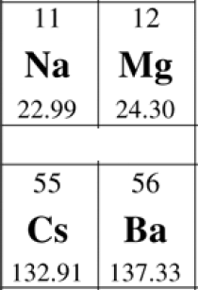
49. | C 32  S = O = 6 valence electrons. Charge of 2- means add two additional electrons.  2(6) + 3(6) + 2 = 32 valence electrons.
50. | A CO₂  For the electron pair geometry to be the same as the geometry of the atoms, there should be no lone pairs of electrons on the central atom. This is only true with CO₂. Draw each one of the choices.
51. | B OF₄  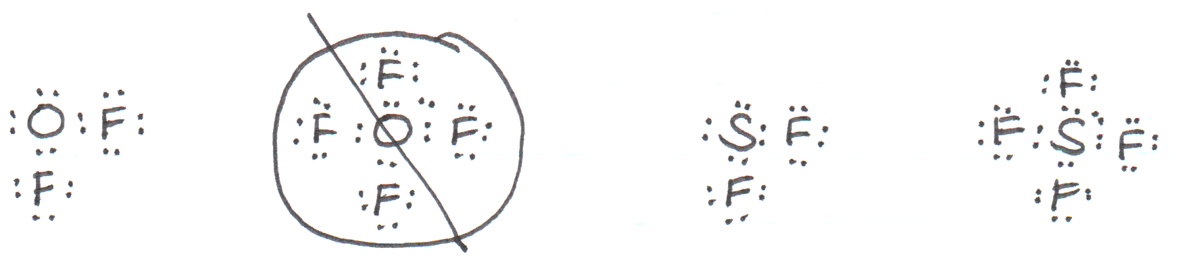  While O and S are in the same family, they cannot always do the same bonding.  S can use “extended valence shells” by promoting some of its valence 3p electrons into the 3d orbital.  O has no d orbital to promote its valence 2p orbitals into.
52. | C H₂O, NH₃, CH₄  Lone pairs of electrons exert more repulsive force than shared pairs of electrons.  The fewer lone pairs result in larger bond angles.  Draw or visualize the Lewis structures to answer. |  |  |  | 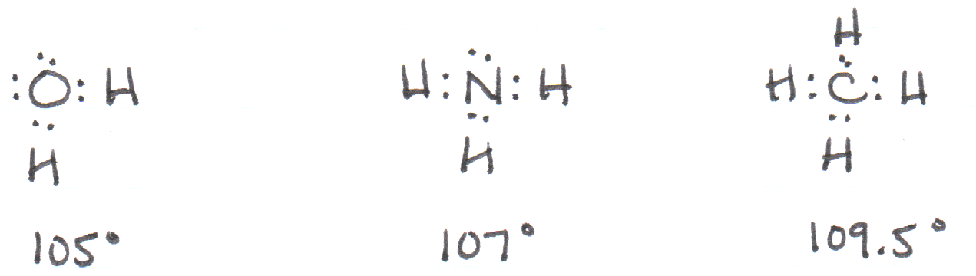
53. | C T-shaped  Draw the Lewis structure.  Cl has 7 valence electrons and uses 3 to form bonds to the three F’s.  Four electrons remain as the two lone pairs. SN=5, the electrons are Δ bipyramidal.  The two lone pairs are in the axial positions, so the atoms are in a T-shape. |  |  |  |  |  | 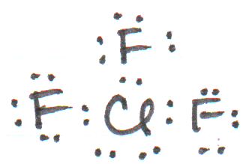
54. | B NaBr, NaCl, NaF  Lattice energy depends on charges and sizes. All of these are 1+ and 1- ions so the size is the determining factor. The smaller the ions, the stronger the attraction. F⁻ is the smallest so it has the strongest lattice energy. Similarly, Br⁻ is the largest ion so it has the smallest lattice energy.
55. | A 14  Each single bond is a sigma bond. Draw the structural formula. |  |  |  | 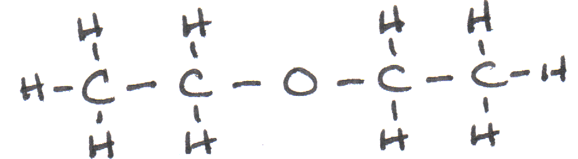
56. | D oxidation  During this change, more bonds are made to oxygen. The carbon atom is oxidized. Complete oxidation leads to CO₂. |  |  | 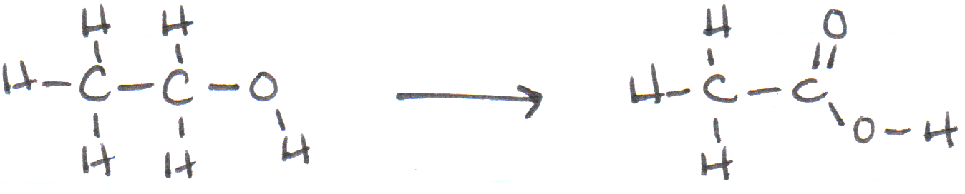
57. | B 3  The five carbon atoms can be put together in three distinct ways: five in a row, four in a row with one methyl groups, three in a row with two methyl groups.  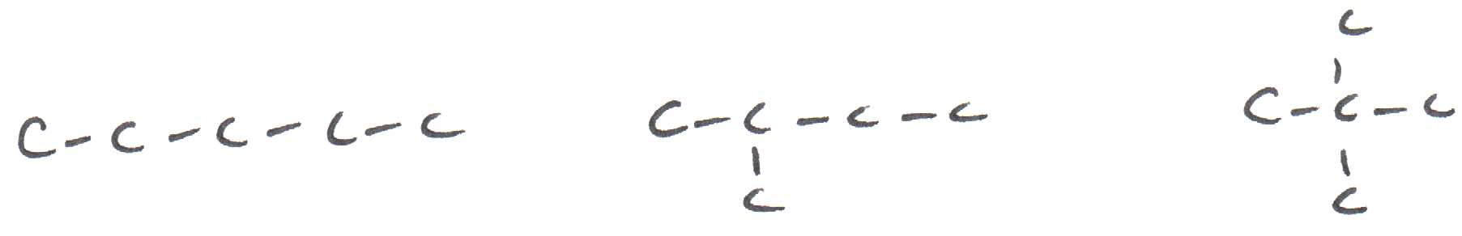
58. | C alcohols, R-O-H  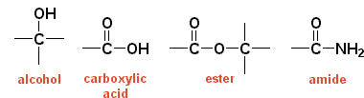
59. | B sp²  Draw the structural formula.  Steric Number on the C is 3.  sp² hybridization. Bond angle 120° (ideally). | 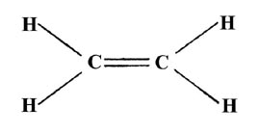
60. | A A peptide bond forms between two amino acids when a H and OH are removed to form H₂O.  OH is removed from the acid group… H is removed from the amino group. The C bonds to N.  

