South Pasadena • Chemistry Name_____________________________________
Period _____ Date ___/___/___
7 • How Do Atoms Stick Together?
LECTURE NOTES B

1. Symmetrical molecules are not polar.
Circle the molecules that ARE polar:
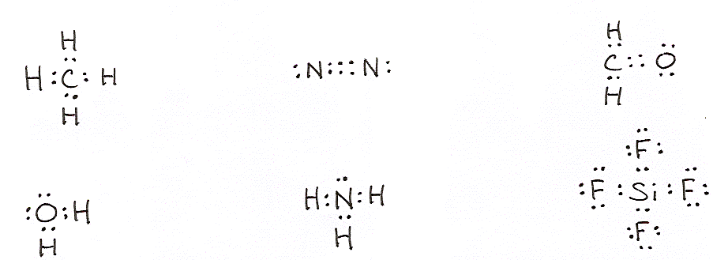

Hydrogen Bonding
There are three cases where molecules are SO polar that they warrant a special name. When H is bonded to N, O, or F, we say the molecules are attracted to each other with hydrogen bonding.

2. The two factors that make N, O, and F special are that they are _____________ (small/large) and _____________ (very/not very) electronegative.

3. Hydrogen bonding is often represented as a __________ _____. Show the hydrogen bonding that would exist between the water molecules below.

O–H O–H O–H O–H
‌| | | |
H H H H

O–H O–H O–H O–H
‌| | | |
H H H H

O–H O–H O–H O–H
‌| | | |
H H H H

4. Consider the four compounds, H₂O, H₂S, H₂Se, and H₂Te. Which one exhibits hydrogen bonding? ______
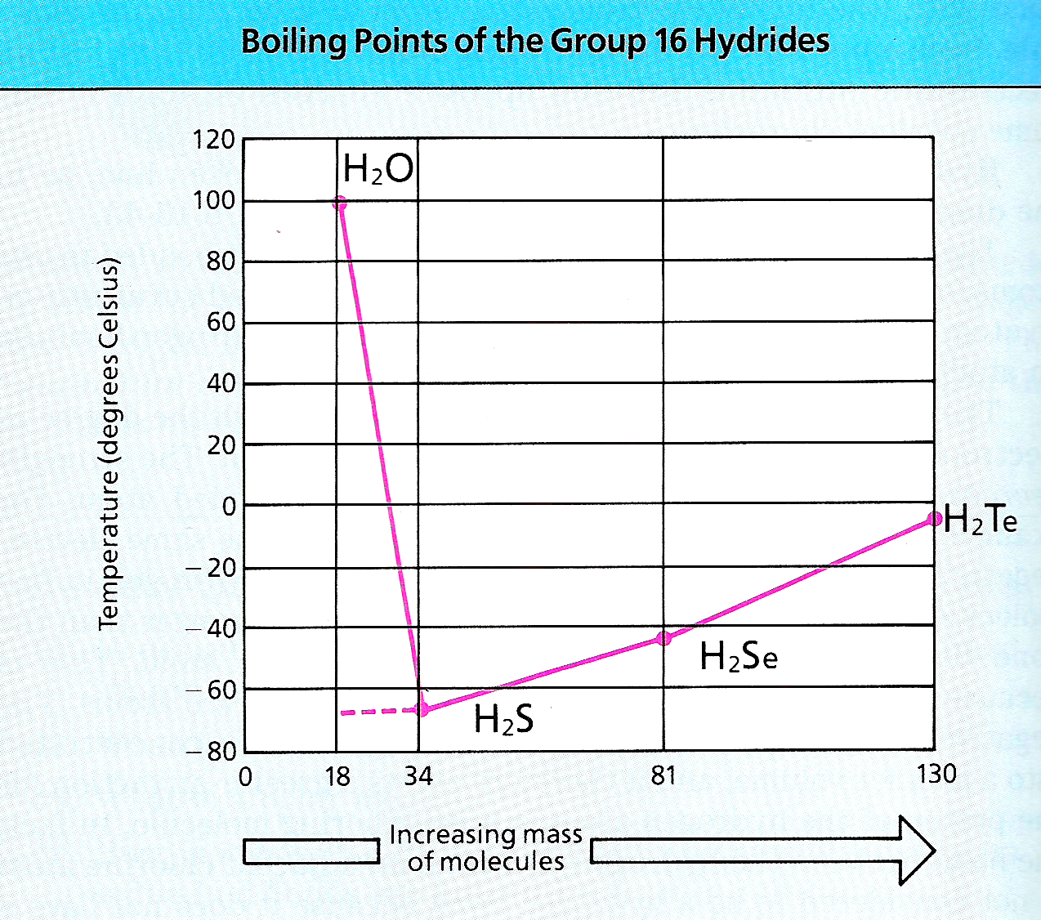
Look at this graph of boiling points. What effect does the hydrogen bonding have? ________________________________________________________________________________
Without hydrogen bonding, you might expect H₂O to have a boiling point of about ______ ºC.

5. Look at this figure from the textbook.
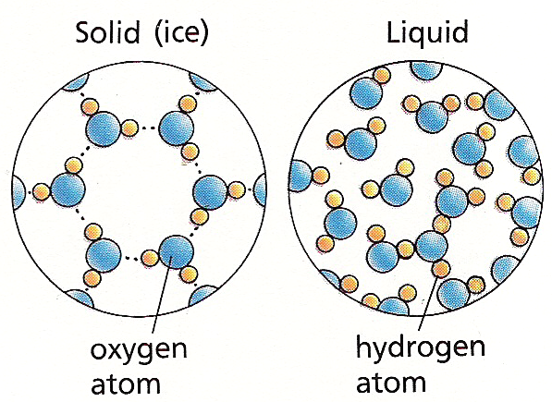
Hydrogen bonding causes the water molecules to align themselves in a very orderly pattern as a ____________ (solid/liquid).

Which of these two phases would take up more room? _________ (solid/liquid). So… as water freezes, it _________ (expands/contrasts).
[Hint: Have you ever left a can of soda or a bottle of water in the freezer? What happens?]

6. Which biological molecules depend heavily on hydrogen bonding to work properly?
___ ___ ___ and ____ ___ ___.

Metallic Bonding
Metal atoms have two properties in common: low electronegativity values and open valence orbitals. Metals are described as a “a lattice of positive ions in a sea of mobile of electrons”. Metallic properties such as conductivity, shininess, and bendability can be understood as a result of this bonding.

7. Look at this figure of a metal.
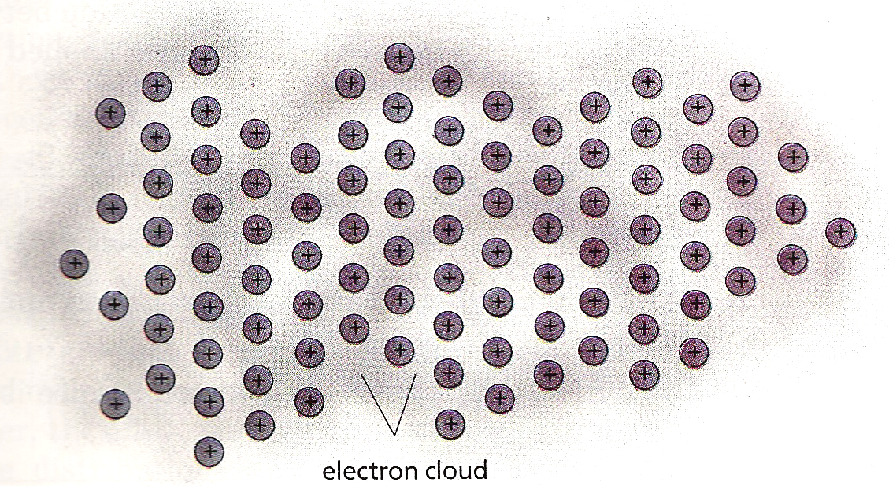
Each ion has a positive charge. Each positively charged ion “feels” a(n) _______________ (attraction/repulsion) for the other positively charged ions.

It is the diffuse cloud of ________ that spend time between the ions that keeps everything bonded together.

8. If the positive ions move a little, can the electrons still hold them together? _____ (yes/no)

9. Define these terms that refer to metals:
malleability-_____________________________
ductility-________________________________
conductivity-_____________________________

10. Heat and temperature are measures of Kinetic energy. Kinetic energy is energy of ________ (motion/position). Metals are good conductors of heat (kinetic energy) because the ________ move easily and transfer the motion energy.

Network Solids
These are elements and compounds that have extended covalent bonding. These form the hardest known substances.

11. Example of network solids are: (fill in the formula)
diamond ______________________
graphite ______________________
quartz ______________________
silicon carbide _________________

Ionic Crystals
The Point:
You can recognize ionic substances because you will see the positive ion and negative ion you have memorized. The arrangement of the ions, their conductivity is solution and melted (but not as a solid), their brittleness, and their ability to dissolve in water are due to their ionic bonds.

12. Electrical conductivity will occur when there are mobile ions. In which cases below are there mobile ions?
solid NaCl (yes/no)
molten NaCl (yes/no)
gaseous NaCl (yes/no)
dissolved NaCl (yes/no)

So, ionic compounds conduct electricity as __________ and ___________ _____________.

