NChO 2007
ANNOTATED ANSWERS

1. | (C) BaCl₂  Use your solubility rules to eliminate precipitates.  AgCl (chlorides are soluble except “AP/H”),  Ag₂CO₃ & BaCO₃ (carbonates are almost always precipitates)
2. | (C) 10 mL volumetric pipet (or pipette)  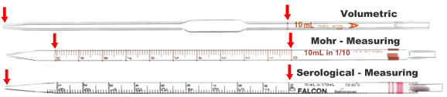Pipettes (fancy name for eye-droppers) are used to transfer liquids. Volumetric pipettes have been carefully calibrated to allow measured amounts to be transferred. This type of pipette has a bubble in the middle to allow larger volumes to be dispensed. The Beral pipet is the plastic disposable kind we use in lab. Using a 1 mL pipet over and over… the uncertainty of each transfer would add up.
3. | (D) NH₃  This is from the “gases that form” section of the Stuff I Am Supposed To Know” sheet.  When you see NH₄OH formed by double replacement, remember that it decomposed into NH3(g) + H₂O.
4. | (A) 1 significant figure  The ΔT is the key here. When you subtract 77.6 mL from 78.1 mL, the answer ends at the first decimal place, 0.5 mL which is one significant figure. Your calculated answer is only valid to 1 sig. fig.
5. | (D) ZnCl₂  From your ion list, you should know that Co²⁺ is pink, MnO₄⁻ is purple, and Cr₂O₇²⁻ is orange.
6. | (B) Rinse it with H₂O followed by a dilute solution of NaHCO₃.  Certainly rinsing the skin with water is the important first step. Neutralizing with baking soda is OK.
7. | (D) 0.276/1  Convert 525 g sucrose to moles. Convert 100. g H₂O to moles.  525g C₁₂H₂₂O₁₁ x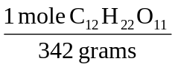= 1.535 mols C₁₂H₂₂O₁₁; 100.g H₂O x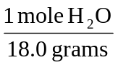=5.556 mols H₂O  The ratio is 1.535:5.555 or 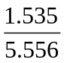: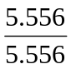 = 0.276 : 1
8. | (B) 537 g/mol
9. | (A) 0.180 M  Calculate moles of NO₃⁻ in each case and divide by the total volume.  Calcium nitrate is Ca(NO₃)₂. 0.100 L x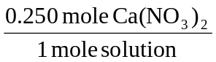x 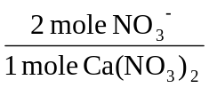= 0.0500 mole NO₃⁻  Nitric acid is HNO₃. 0.400 L x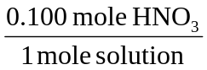x 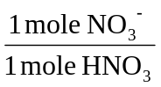= 0.0400 mole NO₃⁻  Total moles = 0.0900 moles NO₃⁻; Total volume = 0.500 L; [NO₃⁻] = 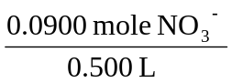= 0.180 M
10. | (A) 0.29 mol  Two given values alerts us that this is a limiting reactant problem.  Calculate the answer with both given values and take the smaller answer.
11. | (B) 4.0 x 10⁻³  Write a half-reaction for the formation of H₂(g) from H⁺. (H has a 1+ oxidation state in H₂O.)  2H⁺ + 2e⁻ → H₂(g).  4.8 x 10²¹ electrons x 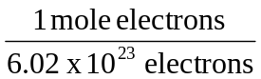 x 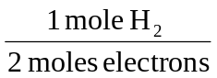= 3.9867 x 10⁻³ moles electrons
12. | 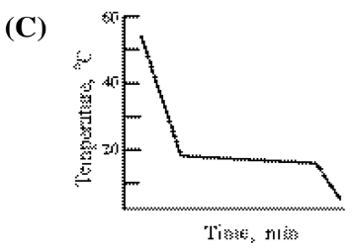 compared to the curve for the pure solvent: 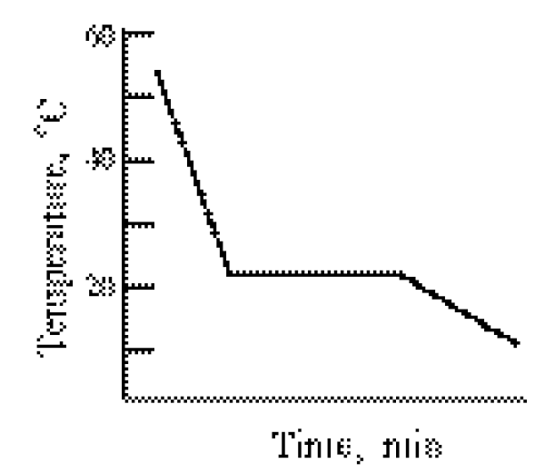  Note: This is not a question where you are supposed to know this graph… you are supposed to apply what you know to what the graph tells you.  Two clues are here. The original curve showed the FP at ∼22°C. The solution should have a lower FP.  Also, the freezing temperature gets lower as the water freezes out and the solution gets more concentrated.
13. | (A) high electrical conductivity  To conduct electricity, ionic compounds need mobile ions. In the solid phase, the ions cannot move.
14. | (A) Ne  You can calculate the answer using Graham’s law of effusion, but you can logic this one out, too.  You want a molecule that is faster than Kr… so it must be lighter than Kr. (eliminate Xe and Rn).  If you recall Graham’s Law, = 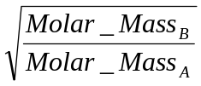, you know that the lighter gas is not ½ the mass, but ¼ the mass. Ne has a mass of 20 g/mol compared to Kr with a mass of about 80 g/mol.
15. | (D) fusion < vaporization < sublimation  Think of the changes involved and how much energy (ΔH) will be involved.  Fusion (melting) is solid→liquid; Vaporization is liquid→gas; Sublimation is solid→gas.  Solid & liquid are both close together so the enthalpy (ΔH) will be smaller than liquid→gas.  Solid→gas (sublimation) must involve the largest change… so eliminate (A) and (B).
16. | (B) 2 only  Hydrogen bonding is the extra strong dipole-dipole attraction between two molecules with H—N, H—O, or H—F. Bonds 1 and 3 would just be covalent bonds.
17. | (C) 831  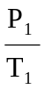= 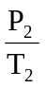 but remember to change 50°C to 323K and 100°C to 373K! P₂ = 720 mmHg x 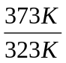  Note: You don’t need to calculate this. The answer will be greater than 720, but not twice as much.
18. | (C) vapor pressure  Recall that as IMF increases, BP, FP, ΔHvap, ΔHfusion, everything increases except vapor pressure.  The particles have a tougher time escaping as vapor if the IMF is larger.
19. | (D) 92.2 kJ  Know that “enthalpy of formation of NH₃(g) implies the equation: ¹/₂N₂ + ³/₂H₂(g) → NH₃(g)  ΔH_{formation} is always for one mole of compound.  To get 2NH₃(g) → N₂(g) + 3H₂(g) you must double the reaction and reverse it: 2 × –(–46.1 kJ) = 92.2 kJ
20. | (C) 0.14  The units give the clue that specific heat capacity, Cp, is 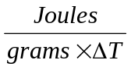 = 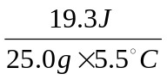= 0.14 J·g⁻¹·°C⁻¹
21. | (A) I only  Just from your experience, you know that combustion is exothermic. Dehydration of a hydrate was done in a summer lab (heating a hydrate in a porcelain crucible to drive off the H₂O). We used CuSO₄·5H₂O, but the fact we had to heat it means it is endothermic.
22. | (B) SO₂(g)  Entropy = randomness or disorder or the number of “microstates”.  Two ideas help. Entropy(gas) > entropy (liquid) > entropy(solid). Eliminate answers (C) and (D).  Since SO₂ is bent and polar compared to O₂, it will have more microstates. SO₂ has greater entropy.  As an analogy, ○ has only one microstate, whereas → could be ← or ↑ or → or ↓.  So, → has greater entropy than ○.
23. | (C) ΔG < 0  ΔG is always negative for a spontaneous (product-favored) reaction. You can find examples where either ΔH or ΔS is + or – in a spontaneous reaction depending on the temperature.
24. | (A) 129.2  This is just Hess’s Law. ΔH_{reaction} = ΣΔH°_{f} of products - ΣΔH°_{f} or reactants.
25. | 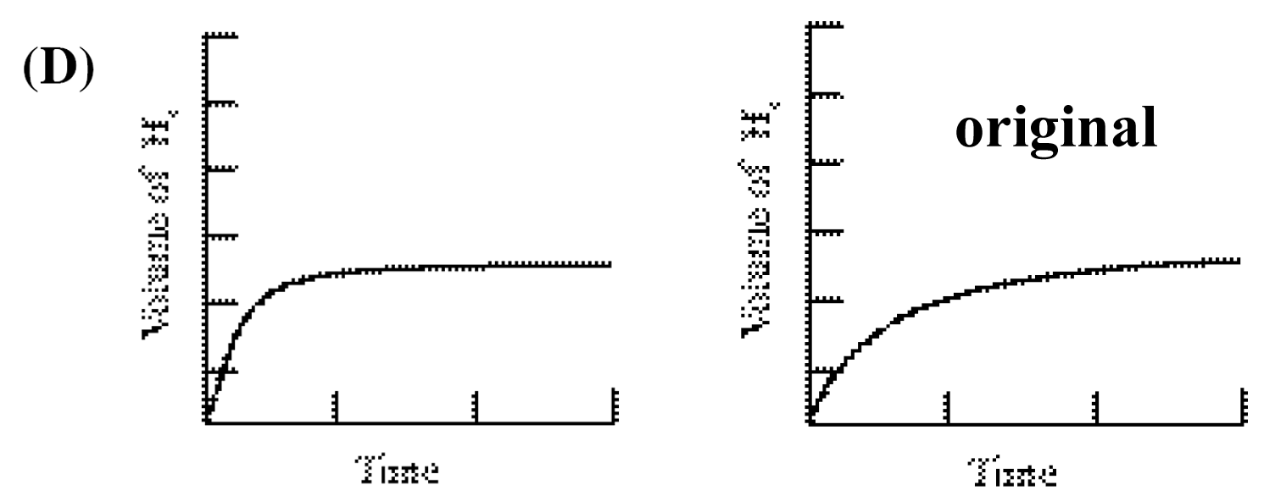  Note: This is not a question where you are supposed to know this graph… you are supposed to apply what you know to what the graph tells you.  Look for an answer that gets to the same final volume of H₂(g), just faster. The Mg(s) is the limiting reagent and will determine the volume of H₂(g). The more concentrated HCl will speed up the reaction.
26. | (C) 0.032  2N₂O₅(g) → 4NO₂(g) + O₂(g) Use the coefficients to change the rate of one chemical to another.  0.016 mol·L⁻¹·min⁻¹ N₂O₅ x 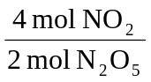 = 0.032 mol·L⁻¹·min⁻¹ NO₂
27. | (D) L·mol⁻¹·s⁻¹  Second Order Rate Equation: Rate = k[R]². Solve for k. k = 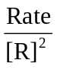so 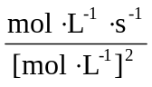= 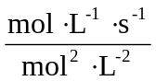  Note: know how to derive the units for these cases and maybe memorize  Zero order 1st order 2nd order  Rate = k Rate = k[A] Rate = k[A]²  k = Rate = mol·L⁻¹·s⁻¹ k = 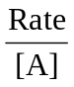= s⁻¹ k = 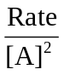= L·mol⁻¹·s⁻¹
28. | (B) 2 min  For first order processes half life is constant. The pictures go from 16→ 8→ 4. The half life is 2 min.
29. | (D) providing an alternate reaction pathway with a lower activation energy.  This is simply the definition of how a catalyst works. Pretty basic.
30. | (D) The reaction mechanism involves more than one step.  The rate law represents the molecularity of the slowest step. Each step in a mechanism, however, involves only two particles (bi-molecular). Since the rate law has three chemicals (two A’s and a B), the mechanism must involve at least two steps.  For example: A + A  X (slow)  X + B → Z (fast)
31. | (A) CaCO₃(s)  CaO(s) + CO₂(g)  Translate “cause a decrease in products” to “shift to the left”.  A decrease in volume will shift the equilibrium to the side with fewer moles of gas.  (B) and (C) the products have fewer moles of gas.  (D) there are two moles of gas on the reactant and product sides of the equation.
32. | (D) hydrocyanic acid  The weakest acid has the smallest K_{a}. 4.9 x 10⁻¹⁰ < 5.8 x 10⁻¹⁰ < 1.5 x 10⁻⁵ < 8.0 x 10⁻⁵.
33. | (D) 7.084  H₂O(l)  H⁺(aq) + OH⁻(aq) K_{w} = [H⁺][OH⁻] = 6.807 x 10⁻¹⁵ at 20.0°C.  [H⁺] = 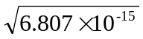 = 8.250 x 10⁻⁸ pH = -log[H⁺] = -log(8.25 x 10⁻⁸) = 7.083522
34. | (C) 0.10 M CH₃COOK (we might write KC₂H₃O₂)  Translate “highest pH” into “most basic”  Look for a base (or the conjugate base of a weak acid… such as acetate ion).  Eliminate (A) CH₃COOH and (B) HCN because they are acids. (Notice their K_{a}’s are given in a table.)  Eliminate (D) NaBr because it is the salt of a strong acid-strong base and will have a pH of 7.  (C) is potassium acetate, CH₃COOK. Hydrolysis occurs: CH₃COO⁻ + H₂O  CH₃COOH + OH⁻
35. | (D) The pH does not change appreciably.  The pH depends on the ratio of HA:A⁻ or B:HB⁺. Diluting the solution does not change this ratio, so the pH does not change. The diluted buffer will have less buffering capacity, however.
36. | (B) 8.8 x 10⁻⁹  This is a 1:2 compound, so K_{sp} = 4s³ (where s is the solubility of the solid).  4(1.3 x 10⁻³)³ = 8.788 x 10⁻⁹
37. | (A) Fe²⁺(aq) undergoes oxidation.  Look at the equation and evaluate each answer. Fe²⁺ → Fe³⁺ which is oxidation.  (B) Fe²⁺(aq) is oxidized, so it is the reducing agent not the oxidizing agent.  (C) H⁺(aq) is not oxidized, it does not change. It has a +1 oxidation state on both sides of the equation.  (D) H⁺(aq) cannot be the oxidizing agent since it is not reduced (or oxidized, for that matter).
38. | (D) ClO₄⁻  Translate: which substance can be reduced but cannot be oxidized… look for Cl in its highest ox. state.  Cl is in family (7A or 17) with 7 valence electrons. Cl’s highest oxidation state is +7, as in ClO₄⁻.
39. | (B) +4  Set this up as an algebra problem: Na₂Ti₃O₇ 2(+1) + 3(x) + 7(-2) = 0 x = +4
40. | (C) 1.84 V  This is a standard cell; calculate the difference in the E°_{reduction} values. 1.50 – (-0.34) = 1.84 volts  Note: If you were asked to write the overall equation, you would flip the Tl⁺ + e⁻ → Tl equation around and multiply it by 3. However, you do NOT change the E°_{reduction} because these have been determined by comparing every half cell to the same standard half cell. The e⁻’s have already been accounted for.
41. | (B) Sn²⁺  Translate: which species has the greatest tendency to be reduced. Look for the reactant in the equation with the largest E°_{reduction}. -0.14 V is larger than -1.03 V. Sn²⁺ + 2e⁻ → Sn
42. | (C) I and II only  Electrolysis uses electricity to cause a chemical change.  A metal cation, such as Cu²⁺ gains electrons to become neutral metal: e.g. Cu²⁺ + 2e⁻ → Cu°.  Choices I and II increase the number of electrons moving through the system, so more metal is deposited.  As the metal’s charge increases, more e⁻’s are required per mole of metal… so less metal is deposited.
43. | (C) 9  This is just a way to test your ability to correctly determine electron configurations.  Phosphorus (Z=15) would be: 1s² 2s² 2p⁶ 3s² 3p³. That is a total of 9 electrons in the 2p and 3p orbitals.
44. | (B) K  Visualize these elements on the periodic table. Elements get larger in the lower periods because they have more layers of electrons. They are also larger on the left side of each period because they have fewer protons in the nucleus pulling on the electron cloud. K is the largest because it is lowest left.
45. | (A) B and Ge  Just know your metalloids (a.k.a. semimetals). | 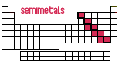
46. | (A) Fe and Ni (These each have 30 neutrons.)  Subtract the atomic number (# protons) from the mass number (# protons + # neutrons) to get # neutrons.
47. | (B) orange light  lowest energy/longest wavelength ROYGBV highest energy/shortest wavelength
48. | (A) [Ar] 3d⁵  Write the electron configuration of the neutral atom  and then remove the three outermost electrons… not necessarily the highest energy electrons.  Fe 1s² 2s² 2p⁶ 3s² 3p⁶ 4s² 3d⁶ or [Ar] 4s² 3d⁶ Lose the 4s² and then one of the 3d electrons.
49. | (D) SO₂  This question is testing your ability to draw Lewis structures. You should memorize CO₂ and SO₂.  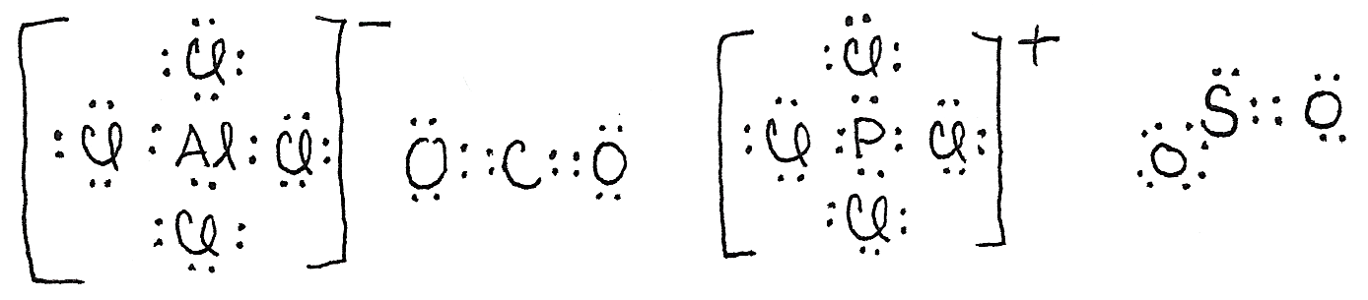
50. | (A) NH₄Br(s)  Polyatomic ions are held together with covalent bonds.
51. | (A) H—F  Notice that these are all acids: H-F, H-Cl, H-Br, and H-I. This is an important clue.  HF is the only weak acid. The others dissociate completely in water. The H—F bond must be strongest.
52. | (C) 120°  Again, this question is testing your ability to draw Lewis structures correctly. NO₂⁻ is analogous to SO₂ in question #49. The steric number is 3, the shape is trigonal planar, and the bond angle is close to 120°.
53. | (B) II only  A resonance structure must have the atoms in the same arrangement… only the electrons shift.  In structure I, the C and N have switched places. These would be two different isomers… not resonance structures of the same substance.
54. | (C) tetrahedral  Draw the Lewis structure. This would be analogous to the AlCl₄⁻ ion shown in question #49.  The steric number is 4, the shape is tetrahedral, the bond angle would be 109.5° and the hybridization would be sp³.
55. | (D) C₈H₁₈  You don’t actually have to visualize this molecule because you know that a saturated hydrocarbon (an alkane) has the formula, C_{n}H_{2n+2}. The only formula that follows this pattern is (D) C₈H₁₈.  A methyl is CH₃- hanging off a parent chain with 5 C atoms. Answer must have 8 C’s.
56. | (C) three  C₃H₈O must have all single bonds (C_{n}H_{2n+2}). The O atom fits between other atoms.  You can make two alcohols (1-propanol, 2-propanol) and one ether (methyl-ethyl-ether).
57. | (D) amine  Know your functional groups. (See the Stuff I Should Know for the AP Test… sheet).  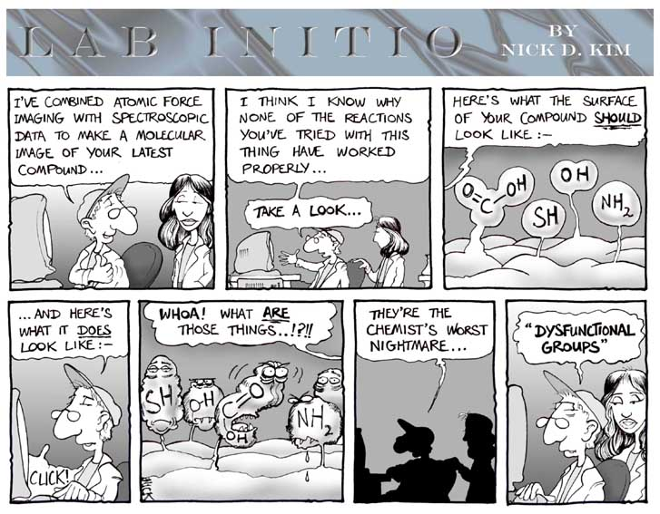  Source: http://www.chemistry.ohio-state.edu/~rzellmer/cartoons/functional_groups.jpg  The artist, analytical environmental chemist, Nick D. Kim: http://www.nearingzero.net
58. | (B) two  This question is testing your organic nomenclature. Do you know that 1-butyne means C≡C-C-C. The triple bond has two pi bonds and one sigma bond. |  | 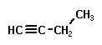
59. | (B) polyethylene terephthalate  This is a condensation polymer (a polyester). This is what water bottles are made of (PETE).  The other three choices are addition polymers… their monomers all contain double bonds.  A Quick Polymer Tutorial: Polymers are long chains formed from monomers.  Plastics are polymers as well as natural substances such as silk, cotton, wool, proteins, starch, and DNA.  Addition polymers begin with monomers that have a double bond. The bond opens up and links with other monomers to form polymers.  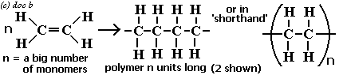  Visit this link to see a great, simple animation of an addition polymerization!   http://www.uwsp.edu/chemistry/tzamis/additionpolymer.html  Many important plastics are addition polymers such as polyethylene (baggies & milk jugs), polystyrene (StyrofoamTM and foam coffee cups), polyvinylchloride (PVC), and TeflonTM.  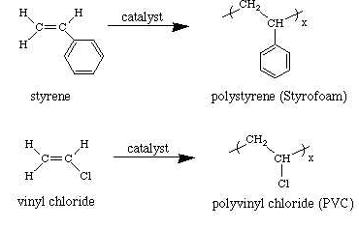  Addition polymers link because of a chemical reaction between functional groups. Polyesters have an ester linkage (acid group + alcohol group → link + H₂O). Each monomer has two functional groups. These two monomers form polyethylene terephthalate (PETE) used for water bottles. Other examples of condensation polymers are nylon, Kevlar (bullet-proof vests), and amino acids forming proteins.  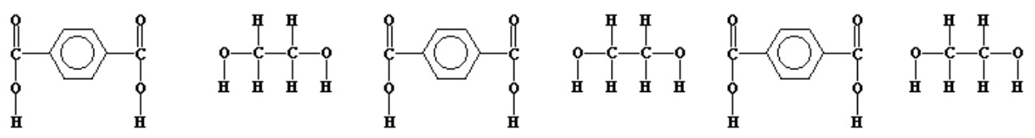  Visit this link to see a great, simple animation of a condensation polymerization!   http://www.uwsp.edu/chemistry/tzamis/condensationpolymer.html
60. | (A) 1, 2, 2  I did trial and error for this one. C₆H₁₂O₆ → 2 C₂H₅OH + 2 CO₂ (fermentation)

